|  |  |
| --- | --- |
| Logo_FPT_University_doc | **MINISTRY OF EDUCATION AND TRAINING** |

**FPT UNIVERSITY**

**CAPSTONE PROJECT DOCUMENT**

**pLED**

**Report #4 – Software Design Description**

|  |  |
| --- | --- |
| **Fast5** | |
| **Group Member** | Nguyễn Thanh Tùng – SE01960 |
| Đinh Quang Hải – SE02354 |
| Đỗ Văn Ban - 01870 |
| Đinh Xuân Bách - 60343 |
| Nguyễn Thế Long – SE02241 |
| **Supervisor** | Mr. Phan Duy Hùng |
| **Ext. Supervisor** |  |
| **Project Code** | pLED |

- Hanoi, 02/2014 –

Table of Contents

[1 ARCHITECTURE DESIGN 3](#_Toc381384792)

[1.1 Choice of Architecture Design 3](#_Toc381384793)

[1.2 Architectural Presentation 3](#_Toc381384794)

[1.3 Component/Package Design 3](#_Toc381384795)

[2 DETAILED DESIGN 3](#_Toc381384796)

[2.1 Common Design 3](#_Toc381384797)

[2.2 Screen Design 4](#_Toc381384798)

[Examples: 4](#_Toc381384799)

[2.3 Schematic board 8](#_Toc381384800)

[2.4 Activity Diagram 11](#_Toc381384801)

[2.4.1 ACT001: Turn On/Off System 11](#_Toc381384802)

[2.4.2 ACT002: Remote System 12](#_Toc381384803)

[2.4.3 ACT003: Setup Time 12](#_Toc381384804)

[2.5 Code-structure diagram 12](#_Toc381384805)

[2.5.1 Analog-clock Mode 13](#_Toc381384806)

[2.5.2 Digital-clock Mode 13](#_Toc381384807)

[2.5.3 Image Mode 14](#_Toc381384808)

[2.5.4 Time-set Mode (Decapitated) 14](#_Toc381384809)

[3 Data-structure design 15](#_Toc381384810)

[3.1 External image 15](#_Toc381384811)

[3.2 Internal array LEDs 15](#_Toc381384812)

# ARCHITECTURE DESIGN

## Choice of Architecture Design

Using state machine structure for a simple system with distinguish functions.

## Architectural Presentation

Hệ thống có 3 lớp:

* Lớp xử lí input, tính toán đầu ra mong muốn của hệ thống
* Lớp xử lí đầu ra, kiểm soát đèn và cách thức hiển thị để có được hình ảnh như mong muốn.
* Driver cho mỗi component

## Component/Package Design

+ RF receiver

+ Real Time Clock

+ Remote controller

+ AC/DC Adapter

+ Motor and stand

# DETAILED DESIGN

## Common Design

A Microchip’s PIC, control the state of 16 RBG LEDs through 6 latches, with precise timing to toggle each led in maximum 24ms. There is a RF component to receive input from user (remote controller) to switch between multiple functions of the device.

## Screen Design

### Examples:

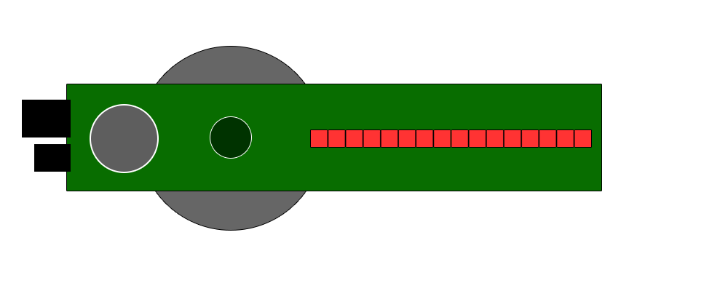

Simplified main component

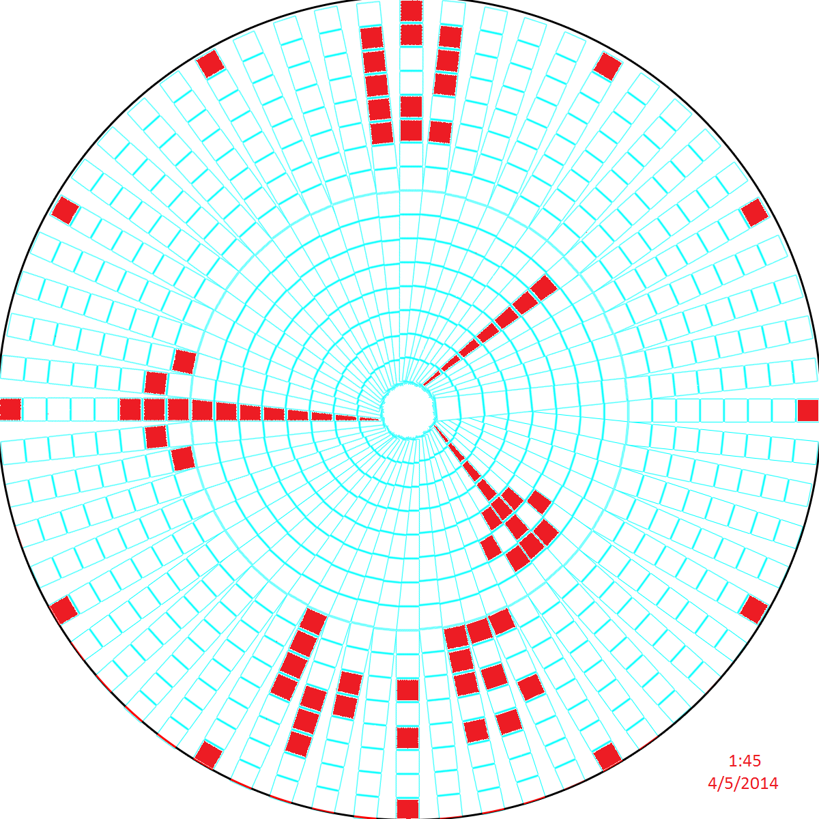

Analog Screen1

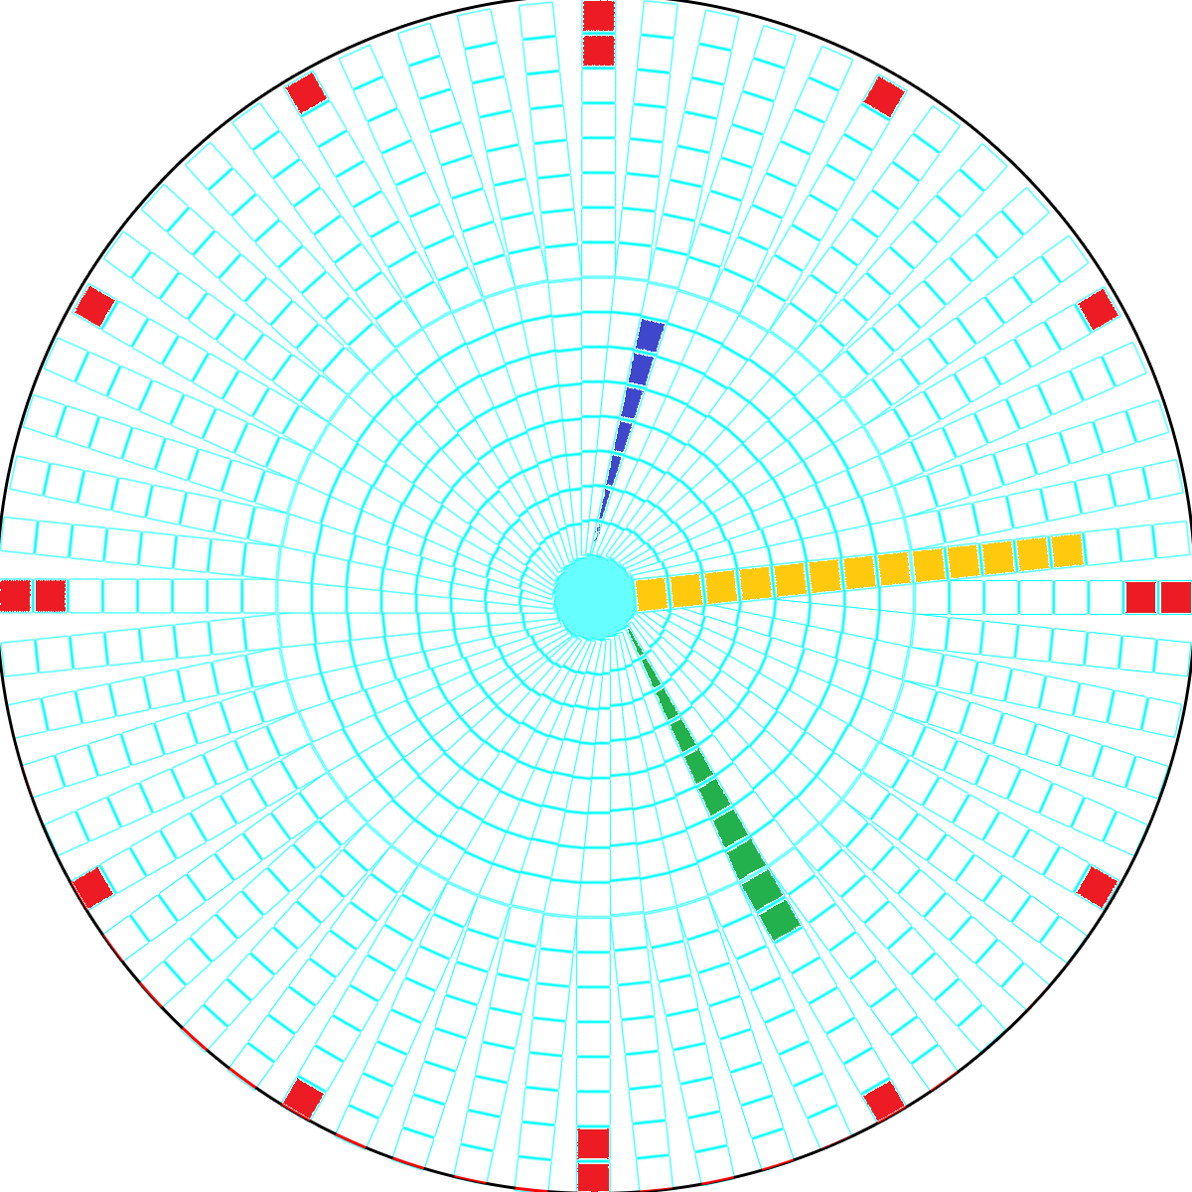

Analog Screen2

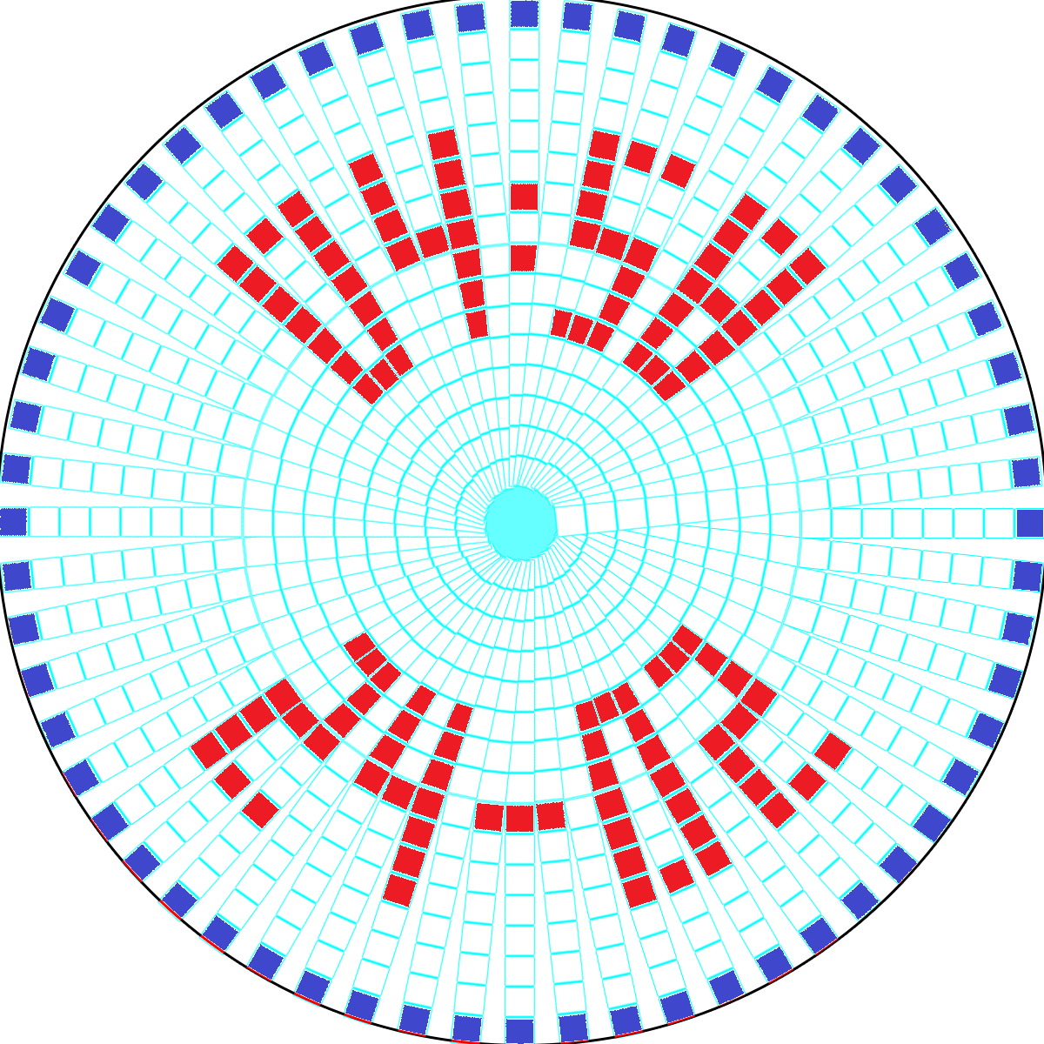

Digital Screen

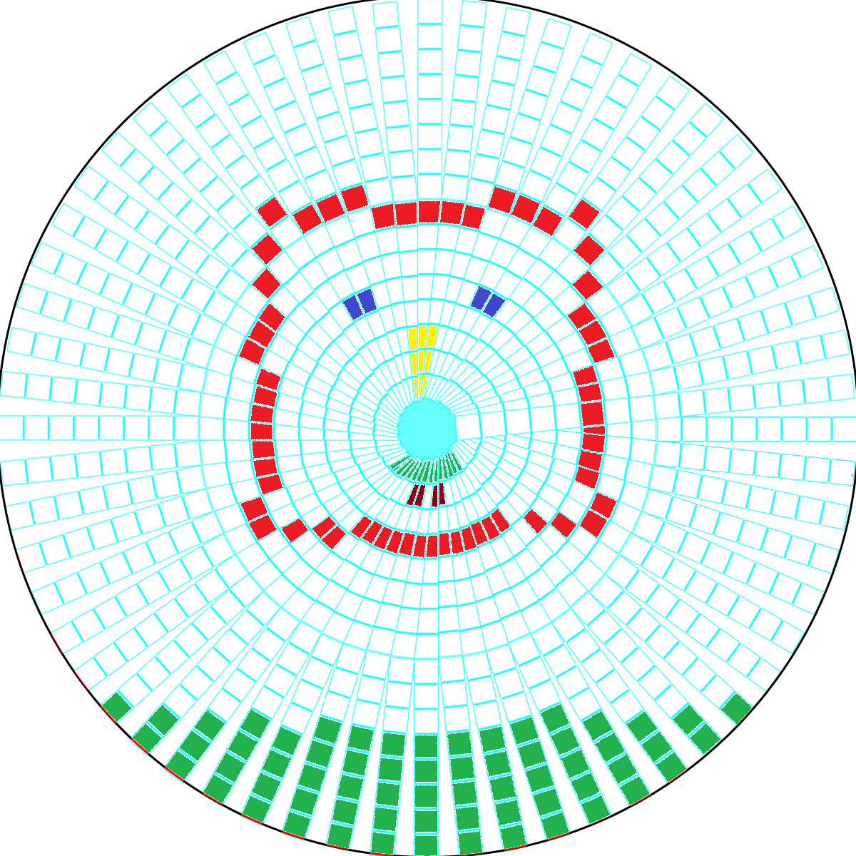

Image Screen

## Schematic board

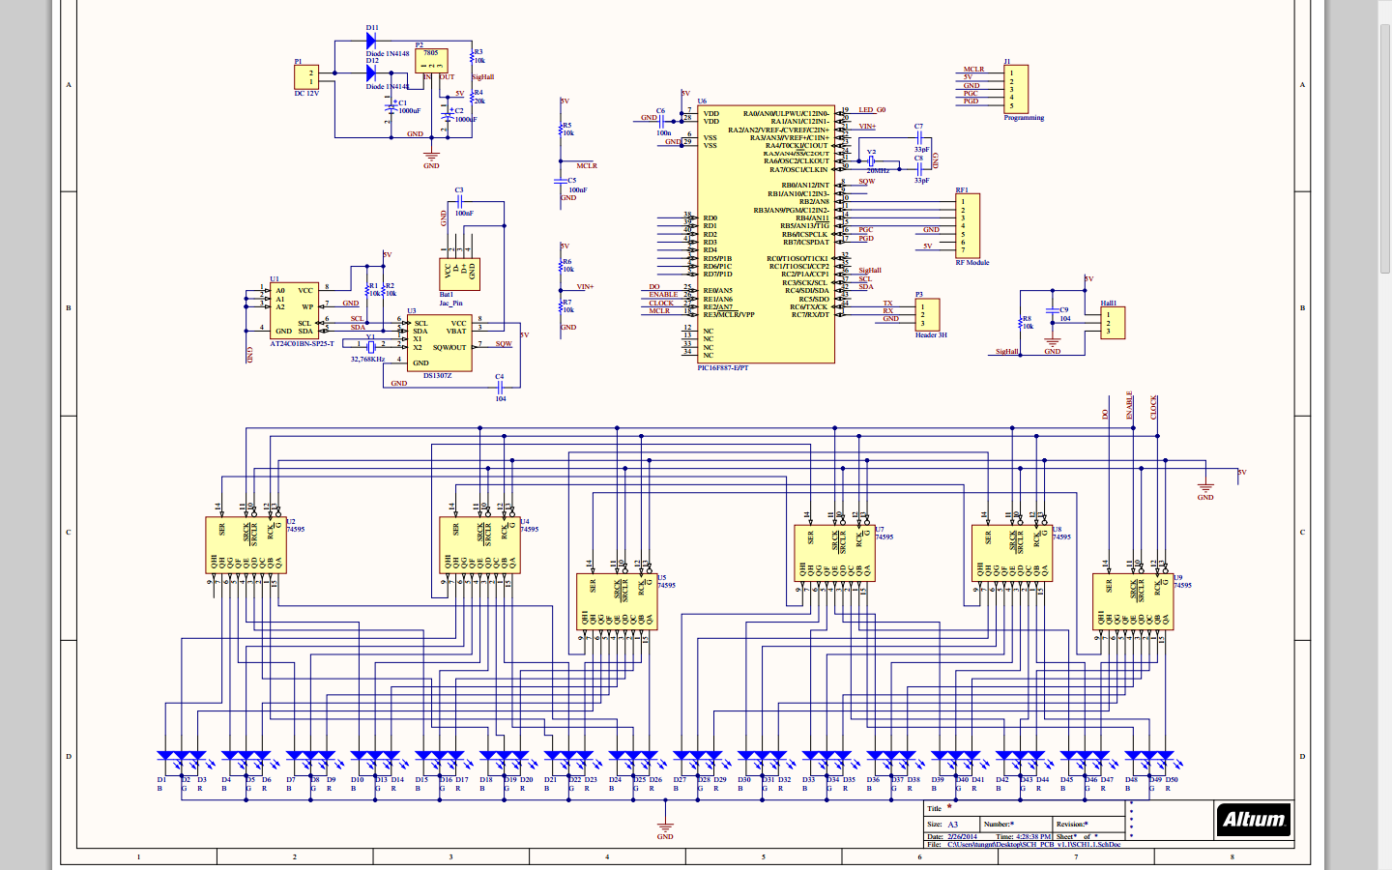

Design PCH

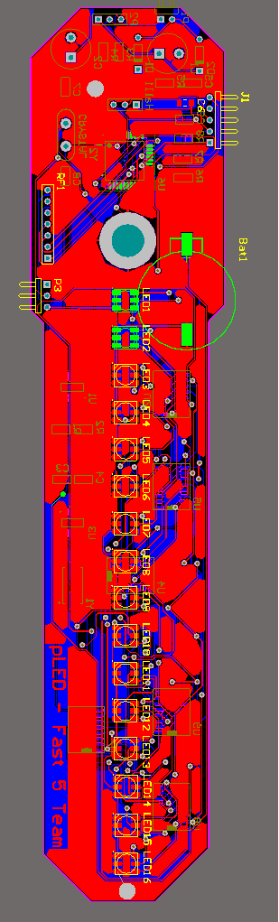

Design PCB FRONT

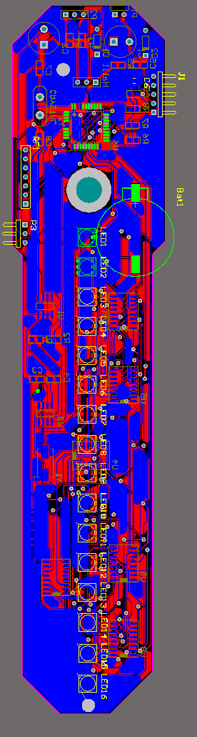

Design PCB BOTTOM

## Activity Diagram

### ACT001: Turn On/Off System

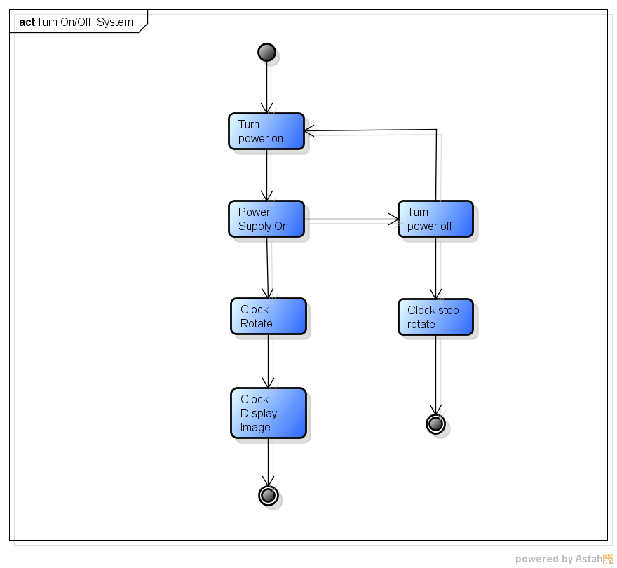

### ACT002: Remote System

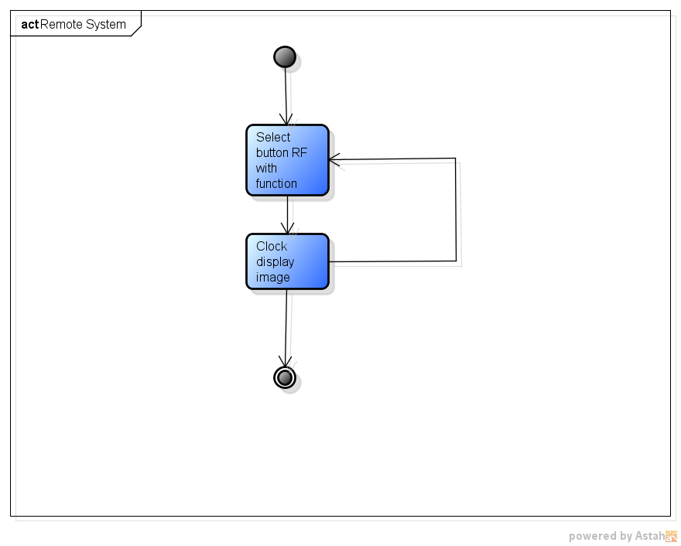

### ACT003: Setup Time

## Code-structure diagram

### Analog-clock Mode

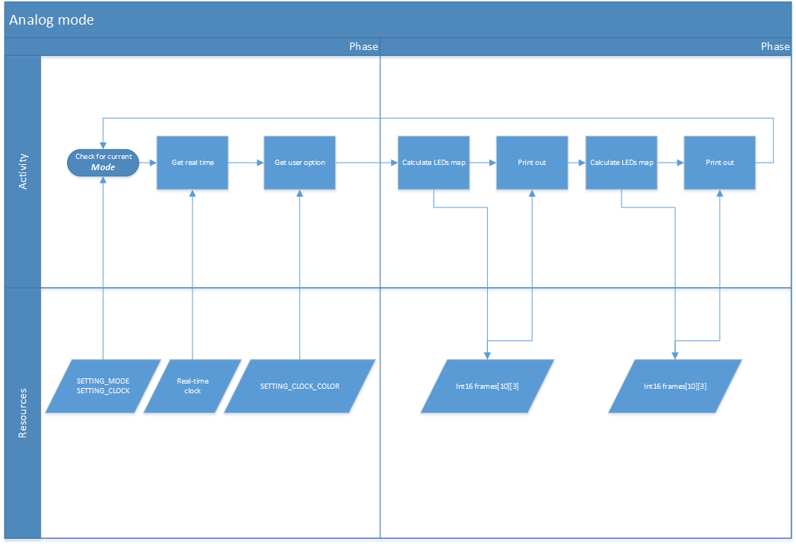

### Digital-clock Mode

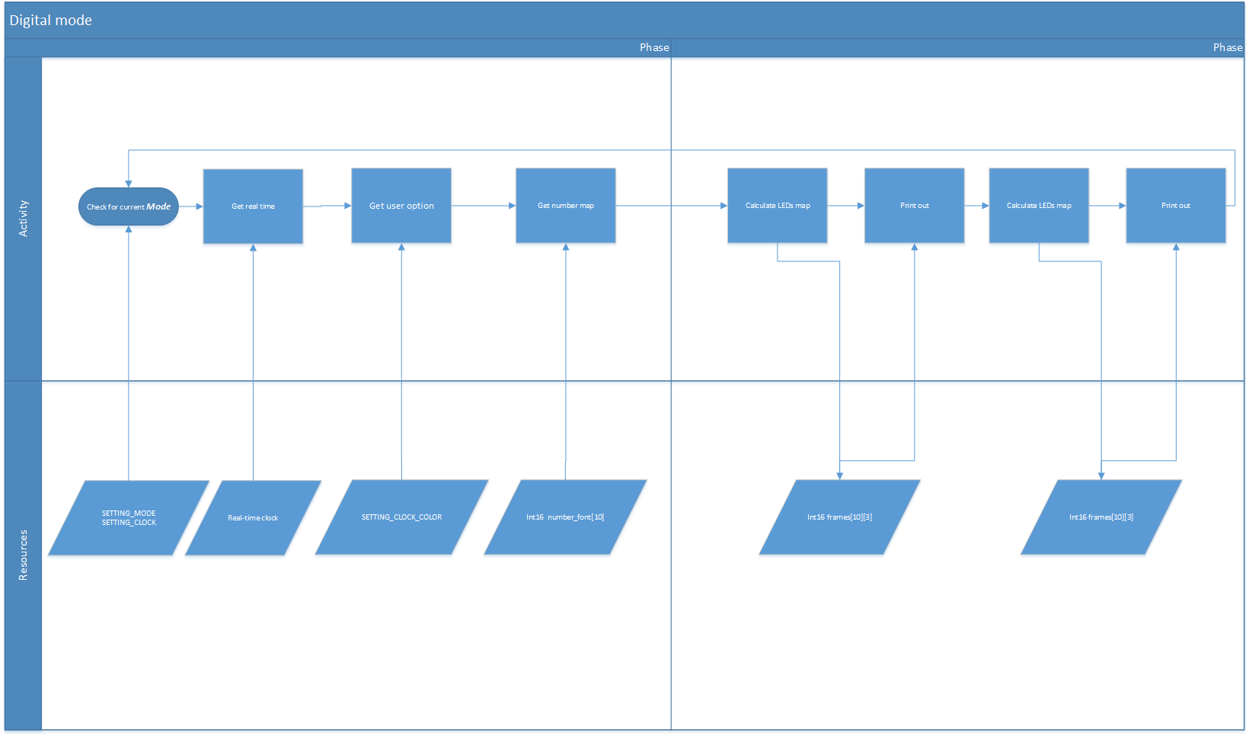

### Image Mode

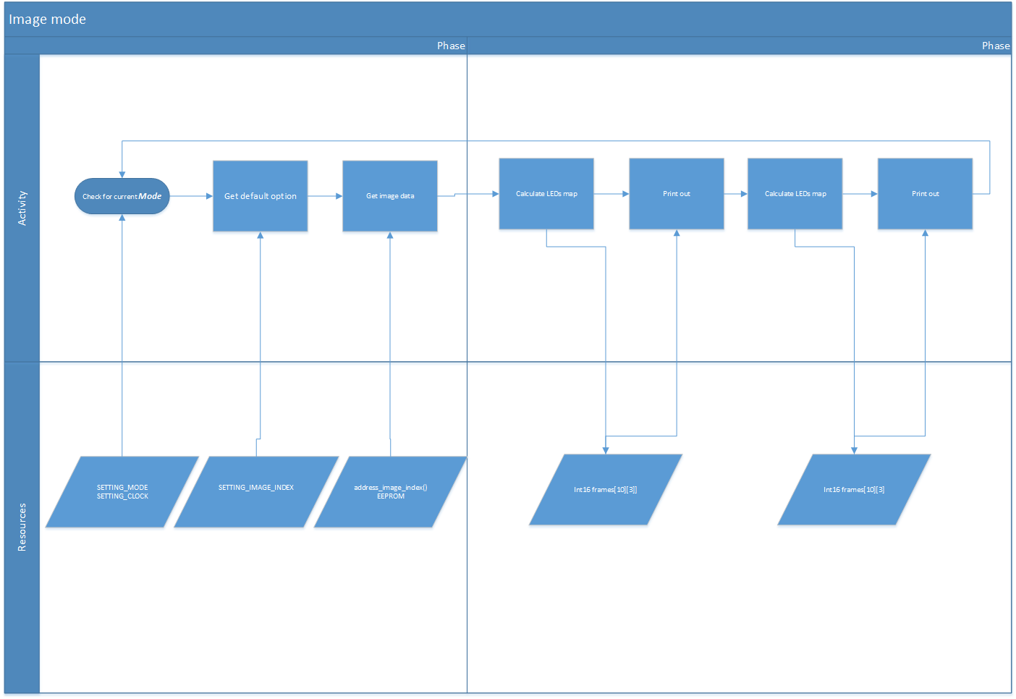

### Time-set Mode (Decapitated)

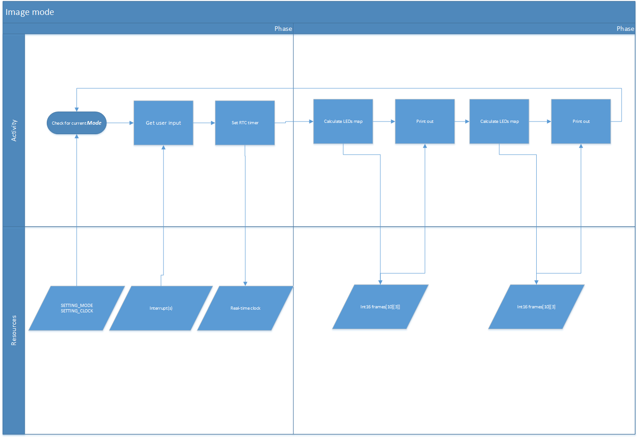

# Data-structure design

## External image

Struct

Int8[a][b] array

ARRAYLED

Struct

ARRAYLED [c] frame

FRAME

[a] = 2 : size of Led Array (2 x 8 bits = 16 leds)

[b] = 3 : color of each array (3 color x 16 leds)

[c] = 60 : number of pieces in each rotation (60 pieces = 60 minutes)

Int8 address

Represent for the address in external EEPROM

## Internal array LEDs

Int16 array

Basic LEDs bits

Int16 frames[10][3]

Represent 1/6 LEDs array of a rotation, for optimizing ram usage.